PART 4: Reflection & Workflow Diagram

4.1 Reflection
The AI development workflow provided several learning experiences, but the most challenging stage was the deployment phase. While data preprocessing, model selection, and training were manageable using standard libraries, deployment required additional considerations such as exposing the model through an API, handling external requests, and ensuring that the model could operate reliably in a real environment. It became clear that a high-accuracy model is not sufficient on its own, successful deployment requires scalability, security, and continuous availability. This made deployment the most complex part of the process compared to offline experimentation.
With more time and resources, our approach could be improved by integrating containerization technologies like Docker and deploying on a cloud platform such as Azure, AWS, or Google Cloud. Furthermore, we would implement automated model monitoring to detect concept drift and performance degradation after deployment. Additional hyperparameter tuning and exploration of more advanced algorithms would also potentially improve accuracy. These improvements would make the pipeline more professional, scalable, and suitable for production-level usage.

4.2 AI Development Workflow Diagram
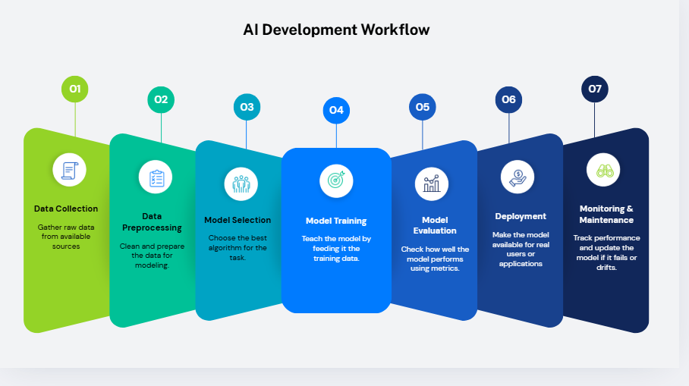Figure 1: General AI Development Workflow
The workflow illustrates the complete pipeline followed during the project. It begins with data collection, followed by preprocessing to clean and transform raw data into a usable format. After model selection and training, the trained model is evaluated using performance metrics. Finally, the model is deployed and monitored to ensure its continued performance over time.

